Axios version 1.2.1

node version 18.12.1

When Axios is used in pure node script, when “axios.get” is called it throws the error:

**AxiosError: unexpected end of file**

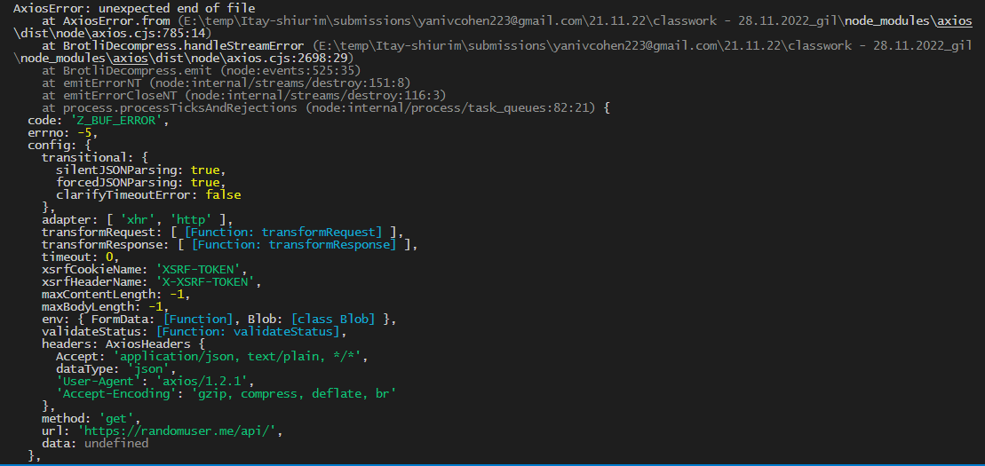

—--------------------------------------------------------—-------------------------------------------------------------

## The solution:

Go to:

node_modules → axios → dist → node → axios.cjs

In the axios.cjs file, find the line:

**streams.push(zlib__default["default"].createBrotliDecompress(zlibOptions));**

It should be line 2637.

In the parentheses of the method call “createBrotliDecompress(zlibOptions)”, delete the parameter “zlibOptions”.

The result should be:

**streams.push(zlib__default["default"].createBrotliDecompress());**

Save the file, the problem must go.